**EXP 9: CREATE A VIRTUAL HARD DISK AND ALLOCATE THE STORAGE USING VM WARE WORKSTATION.**

**DATE: 3-10-2025**

**AIM:**

To create a virtual hard disk and allocate the storage using vm ware workstation

**PROCEDURE:**

**STEP 1:** GOTO VM WARE WORKSTATION.

**STEP2:** RIGHT CLICK THE VM AND GOTO THE SETTINGS.

**STEP 3:** ADD HARDWARE WIZARD AND SELECT SCSI AND CLICK NEXT.

**STEP 4:** CREATE NEW VIRTUAL DISK.

**STEP 5:** SELCT THE DISK SIZE AS 2.0. AND SELCT SPLIT VIRTUAL DISK INTO MULTIFILES.

**STEP 6:** GIVE NAME AND CLICK THE FINISH.

**IMPLEMENTATION:**

**STEP 1: GOTO VM WARE WORKSTATION**

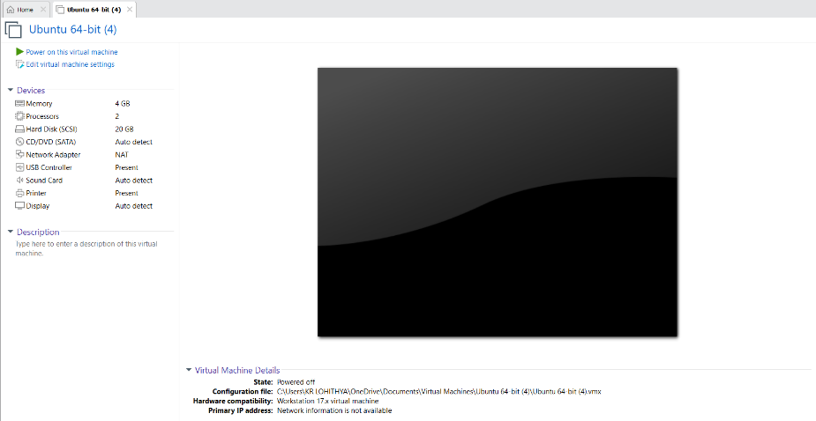

**STEP2: RIGHT CLICK THE VM AND GOTO THE SETTINGS**

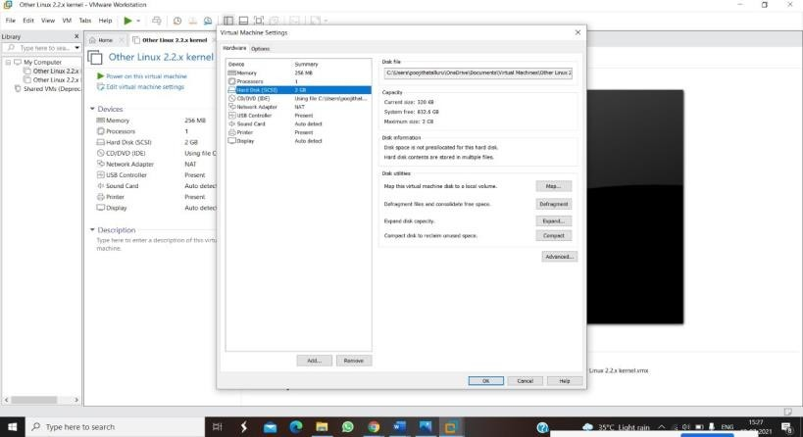

**STEP 3: ADD HARDWARE WIZARD AND SELECT SCSI AND CLICK NEXT**

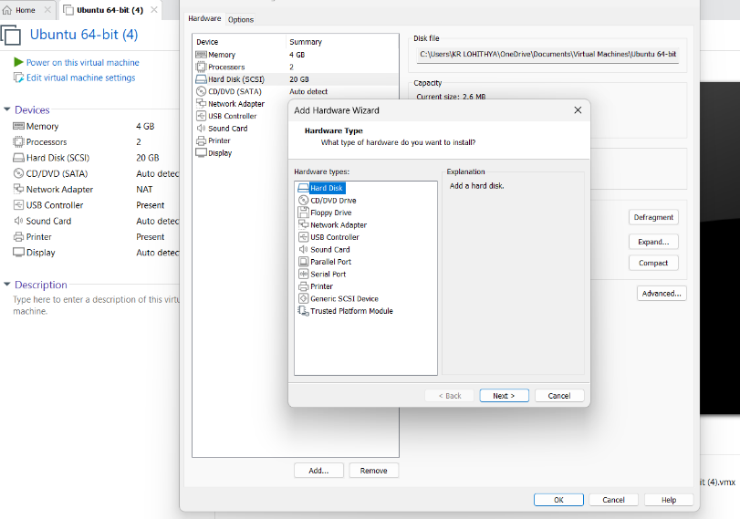

**STEP 4: CREATE NEW VIRTUAL DISK**

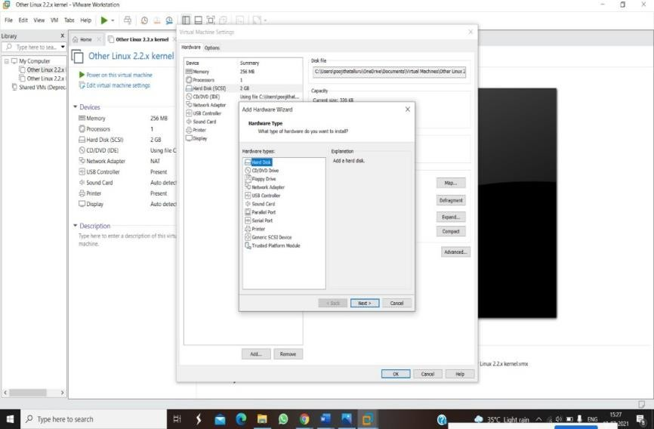

**STEP 5: SELCT THE DISK SIZE AS 2.0. AND SELCT SPLIT VIRTUAL DISK INTO MULTIFILES**

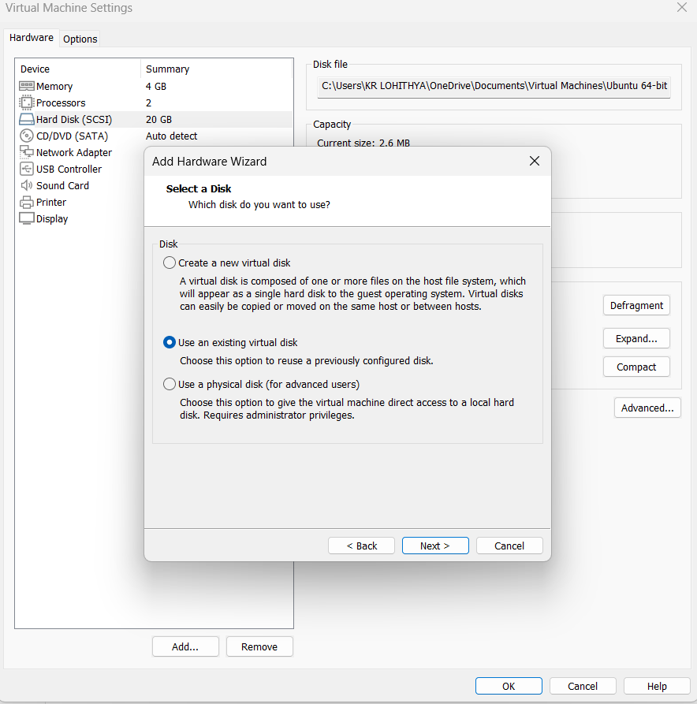

**STEP 6: GIVE NAME AND CLICK THE FINISH**



